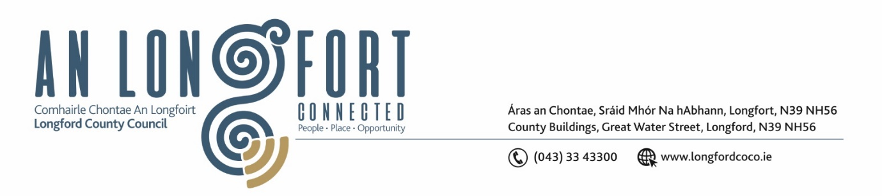

***Please note meeting will be held in the Council Chamber and via Microsoft Teams.***

3 March 2022.

**Chuig: Gach Ball don Chomhairle.**

A Chomhairleoir,

Iarrtar ort bheith i láthair ag Cruinniú Míosuil Chomhairle Chontae Longfoirt a tionólfar i Seomra na Comhairle, Aras an Chontae, Longford agus via MS Teams are an **Chéadaoin 9ú Mhárta 2022 ag** **3pm** chun gnó a dhéanamh d’réir an Chláir thíos.

You are requested to attend the Monthly Meeting of Longford County Council to be held in the Council Chamber and **via Microsoft Teams** on **Wednesday 9 March 2022 at 3pm** to transact business, as set out on the Agenda hereunder.

Mise le meas,

*Ann Marie Mc Keon*

**__________________**

**Ann Marie Mc Keon**

**Meetings Administrator.**

**C L Á R**

Prayer before meeting.

**1.** Confirmation of Minutes of Monthly Meeting of Longford County Council held on 16

February 2022– copy enclosed.

**2.** Matters Arising.

**3.** Declaration of Interest by Members.

**4.** To note Management Report – enclosed.

**5.** To note adopted Minutes of Corporate Policy Group Meeting held on the

18 January 2022 – enclosed.

**6. Finance**

**(a)** Capital Budget 2022 – 2024.

**7. Planning and Project Delivery**

**(a)** To note Planning Applications received since last meeting of the Council.

**8. Community, Corporate and Enterprise**

**(a)** Political Donations - Local Elections (Disclosure of Donation and Expenditure) Act

1999, as amended - Third Parties – enclosed.

**(b)** Consideration to approve grant under the 2022 Intercultural Grants Scheme – enclosed.

**9. General**

Notice of Motions, submitted by Councillors, as listed hereunder –

**Councillor Uruemu Adejinmi**

“I call on Longford County Council to make Longford “breastfeeding friendly” by

signing up for the “We’re Breastfeeding Friendly” initiative and invite local businesses

to do the same. The most recent figures from the Irish maternity indication system show

that in 2019, 62% of mothers had initiated breastfeeding after birth. Within 72 hours of

discharge that drops to 42%. At 3 months the figures are 31.2% and by 6 months just

6% of mothers here will be breastfeeding. The recorded figures for Longford mothers

breastfeeding at 3 months is 23.4% and therefore below the national average.

Embarrassment at feeding in public and fear of negative attention has repeatedly been

cited in Irish studies as a factor in women choosing not to breastfeed. While the

situation is extremely complex, a breastfeeding friendly initiative can only serve to

support those mothers who do choose to continue their breastfeeding journey after

discharge from hospital. Longford has a vibrant community of mutually supportive

breastfeeding mothers who have maintained online support groups and chat groups

throughout the pandemic. It is well recognized the profound impact that public health

restrictions have had on pregnant and expectant mothers. As these groups begin to

reconvene in person it is a timely move for Longford to adopt the “We’re breastfeeding

Friendly” initiative and commit to supporting our local breastfeeding mothers.

Businesses across Longford have long welcomed groups and individuals informally in

this manner and a formal recognition would serve to reinforce this openness and

welcome.”

**10. Correspondence**

Correspondence dated 17 February 2022 received from the Minister of Transport Re M4 Funding - Notice of Motion from Councillor Paul Ross – enclosed.

Correspondence dated 3 March 2022 received from Irish Water Re Meeting with Elected Members – Notice of Motion from Councillor Peggy Nolan – enclosed.

**11. Training**

**12. Votes of Sympathy**